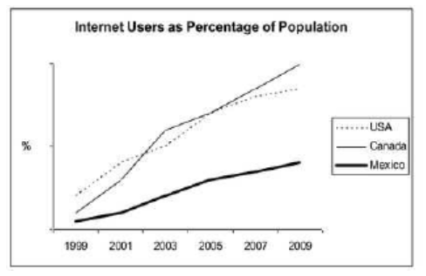

The line graph compares the percentage of people in three countries who used the Internet between 1999 and 2009.

It is clear that the proportion of the population who used the Internet increased in each country over the period shown. Overall, a much larger percentage of Canadians and American had access to the Internet in comparison with Mexicans, and Canada experienced the fastest growth in Internet usage.

In 1999, the proportion of people using the Internet in the USA was about 20%. The figures for Canada and Mexico were lower, at about 10% and 5% respectively. In 2005, Internet usage in both the USA and Canada rose to around 70% of the population, while the figure for Mexico reached just over 25%.

By 2009, the percentage of Internet users was highest in Canada. Almost 100% of Canadians used the Internet, compared to about 80% of Americans and only 40% of Mexicans.

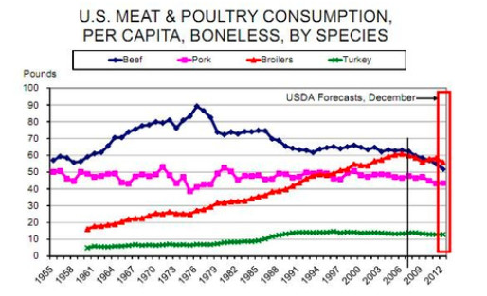

The line graph shows changes in the per capita consumption of beef, pork, broilers and turkey in the United States between 1955 and 2012.

It is noticeable that beef was by far the most popular of the four types of meat for the majority of the 57-year period. However, a considerable rise can be seen in the consumption of broilers, with figures eventually surpassing those for beef.

Between 1955 and 1976, US beef consumption rose from around 60 to a peak of 90 pounds per person per year. During the same period, consumption of broilers also rose, to nearly 30 pounds per person, while the figures of pork fluctuated between 50 and 40 pounds per person. Turkey was by far the least popular meat, with figures below 10 pounds per capita each year.

By 2012, the amount of beef consumed by the average American had plummeted to around 50 pounds, but the consumption of broilers had doubled since the 1970s, to approximately 55 pounds per capita. By contrast, there were no significant changes in the trends for pork and turkey consumption over the period as a whole.